**Form**

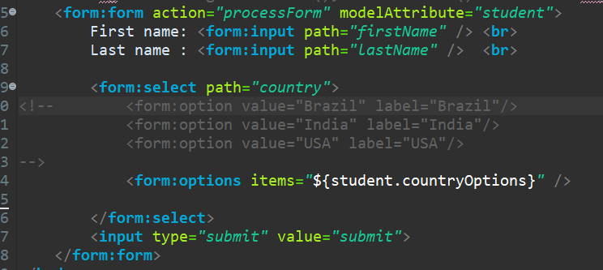

**Student class**

Note:- When doing only thr html then no change is required here

package com.luv2code.springdemo.mvc;

import java.util.LinkedHashMap;

/*

modelAttribute in jsp states which obj will be used to set/get form attributes

when form is loaded it used getters of attributes to get values. If its null then the field is set empty

eg it calls getFirstName(), setFirstName() of student obj got frm controller

*/

public class Student {

private String firstName;

private String lastName;

private String country;

private LinkedHashMap<String,String> countryOptions;

public Student() {

// to insert values for dropdown

countryOptions = new LinkedHashMap<>();

countryOptions.put("BR", "Brazil");

countryOptions.put("IN", "India");

countryOptions.put("FR", "France");

}

public String getFirstName() {

return firstName;

}

public void setFirstName(String firstName) {

this.firstName = firstName;

}

public String getLastName() {

return lastName;

}

public void setLastName(String lastName) {

this.lastName = lastName;

}

public String getCountry() {

return country;

}

public void setCountry(String country) {

this.country = country;

}

public LinkedHashMap<String, String> getCountryOptions() {

return countryOptions;

}

}